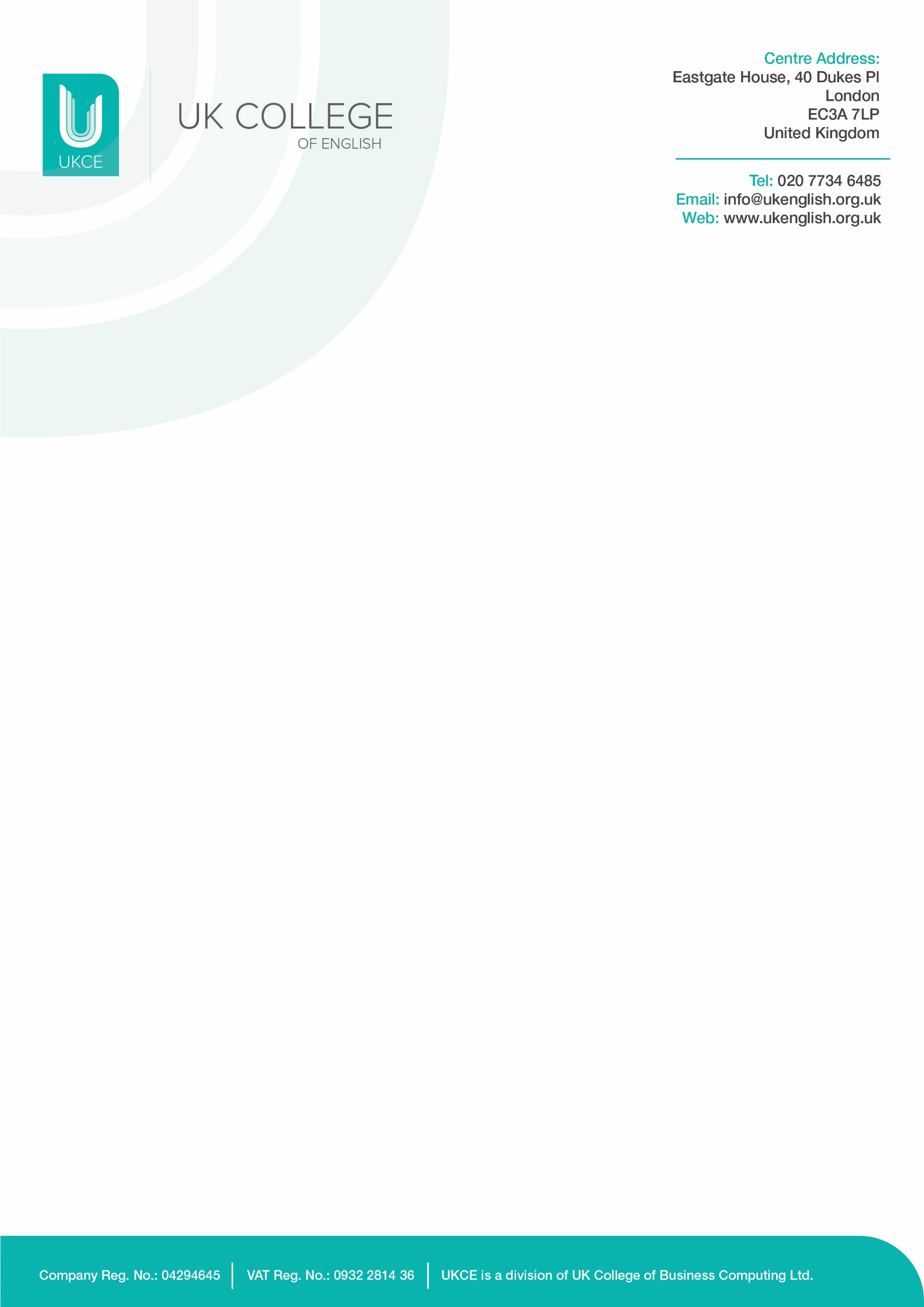

Condensed Safeguarding Policy
Statement
UKCE is committed to assuring the provision of safety and security for persons under 18 (henceforth U18) and vulnerable people across all remits through effective inspection, regulation and supervision. The safeguarding and welfare of U18s and vulnerable people is extremely important and all staff must be aware of their legal duty of care, under the Children Act 2004, in this regard.

Code of Conduct
- UKCE staff are in a ‘Position of Trust’ concerning their students. This makes any sexual activity with students aged under 18 illegal, according to the Sexual Offences Act 2003.
- Appropriate behaviour must be observed with U18s. This includes but is not limited to: the avoidance of inappropriate references to sex and drugs in class, management of other students to do likewise, and the avoidance of unnecessary physical contact with U18s. It is paramount to maintain a demeanour of friendly but professional neutrality with U18s.
- Private contact with under 18s, outside of the bounds of the school, whether in person, by phone or by private social media is forbidden.
- Staff have a duty to report concerns where U18s are displaying signs that might indicate abuse or neglect, as discussed in safeguarding training. These can either be witnessed by or reported to a staff member. Please request a refresher if these signs have been forgotten.
- Staff should be aware that UKCE has a Whistleblowing Policy to protect them if they report concerns.
- Staff should also be aware of new legislation that is relevant to the care of U18s, namely the Counter Terrorism & Securities Act 2015.
- Guidance about the potential dangers of social media should be offered as appropriate.

Designated Safeguarding Staff (DSS)
The designated safeguarding staff, who have all received Level 3 safeguarding training are the Designated Safeguarding Lead, Stephanie Day (the Head of Studies) and Basrie Beren Rashit is Designated Safeguarding Deputy and currently holds the emergency line number at 07956 190 553, and a designated WhatsApp is available for students who cannot access UK phone networks.
The Local Safeguarding Children Board to which allegations of abuse of U18s (if none of the DSS are available) should be reported is:
- Where there is a concern about the behaviour of an adult then contact the LADO (Pat Dixon) on Pat.Dixon@cityoflondon.gov.uk.
- Where there is an immediate concern about a child then contact our Duty Team Child protection - City of London on 020 7332 3621 (Monday to Friday, 9am-5pm only) or 020 8356 2710 (at all other times).

How to respond to a disclosure of abuse from an U18
- Stay calm
- Try to take the U18 to a semi-private area
- Just listen and don’t express disbelief or outrage
- Reassure that only people that need to know will be involved
- Never promise confidentiality
- Report to DSS
- Don’t tell other staff

Students that are aged Under-18 are no longer allowed to join our General English adult classes but instead we hold closed groups in our Soho Campus.
Procedure for Students aged under 18 in closed groups
- Teachers should be aware of the group leaders’ responsibilities.
- Group leaders and teachers need to obey the adult to U18 supervision ratio of 1:10 for 10 – 16-year-olds and 1: 15/20 for 16 – 18-year-olds.
- Group leaders should stay with their students during breaks.
- The U18 students will be reminded to wear a red lanyard badge, this is how we mark U18s students at UKCE.
- Registers should be completed as soon as possible by the teacher and any missing student highlighted straight away and brought to the attention of the Head of Studies/Safeguarding Lead.
- Absence for U18 students will be identified immediately by the teacher/reception staff and followed up by a call to the next of kin.
- At registration, U18s will be given a parental consent form to confirm they mature enough to make their way to and from class and to go for breaks without accompaniment.
- Id students are under the age of 14 then either a Group Leader must accompany them going to the toilet or a buddy system is put into place so that they do not go to the toilets alone.
- U18s will not be allowed to go to the social programmes with adult students without a parental consent form.

Prevent (counterterrorism and Security Act 2015)
At UKCE, we promote the core British values of
Rule of law Democracy Individual liberty Mutual tolerance and respect
We consider vocal / active opposition to these values to be extremism. Whether it is racism, homophobia, or religious ideology, and define radicalisation as the process of leading others towards extremism. Teachers should report any incidence of this to the PREVENT officer, Stephanie Day (Head of Studies), who will take further action as necessary.
Teachers should take opportunities to promote the British values stated above as well as British culture. The Academic Team can advise on additional resources for this purpose.

Lines of Communication

Residential Stay

Ordinary Procedure
Emergency Procedure

Student
Group Leader
Next-of-kin
UKCE

Homestay

Ordinary Procedure
Emergency Procedure

Homestay Host

The Accommodation Agency

UKCE

Student
Group Leader

Next-of-kin

For the full UKCE Safeguarding Policy please see our website:
https://www.ukenglish.org.uk/safeguarding

I have read, understood, and agree to abide by the code of conduct, as well as the procedures for disclosure by U18s and their inclusion in class. I am aware that the full UKCE policies for Safeguarding and Whistleblowing are available on request.

Staff member name: ____________________________________________
Staff member signature: ____________________________________________
Date: ____________________________________________

